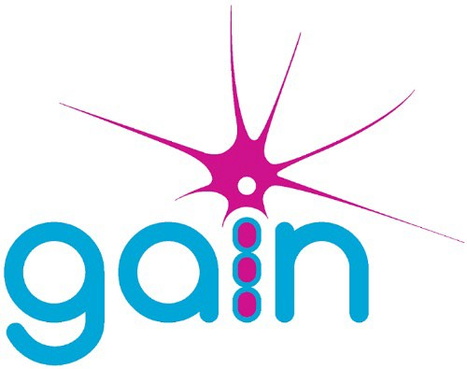

Minutes of the GAIN Annual General Meeting Held on 8 October 2022 at Glennys Sanders House, Pride Parkway, Sleaford NG34 8GL

- Chairman’s Welcome
Chairman Chris Fuller Welcomed everyone and commented on the difference a few years makes to attendance at the AGM from the 100+ in Bournemouth to the 16 in attendance in 2022. Postal and electronic votes had been received and counted. The votes cast represented 17% of the total number of voting members.

Apologies for absence
The following apologies were given:
Mr L Simpson | Russell B Hamilton | Jenny Calder-Smith
Tony Roberts | Norman Druce | Ruth Mcpherson
Jatinder Paul | Susan McAlister | Jane Ware
Edris Houlden

Receipt and adoption of the Examined Accounts for 2021- 2022
The Treasurer, David Wada, gave an overview of the years account and confirmed that they had been independently examined. The Treasurer confirmed that the accounts had been produced and examined by the accountants in accordance with SORP and would be signed off following the adoption of the accounts by the members.

Motion: That the annual accounts for the period 1 April 2021 to 31 March 2022 be adopted. Proposed by David Wada and Seconded by Howard Sanders

The result of the vote to adopt the Examined Accounts was: -
  - For – 29 Against - 0 Abstentions – 0 Spoilt paper - 1

Receipt and adoption of the Trustees’ Annual Report for 2020 – 2021

Motion: That the annual report for the period 1 April 2021 to 31 March 2022 be adopted. Proposed Chris Fuller and Seconded by Jenny Willison

The result of the vote to adopt the Annual Report was: -
  - For – 29 Against – 0 Abstentions – 0 Spoilt paper - 1

Election of Trustees

Robin Shepherd had resigned from the Board, Susan McAllister resigned from the Board after the voting papers had been issued, her resignation was accepted and so any votes for her have been withdrawn. All nominees were duly elected. Vacancies on the Board would be advertised in due course

The result of the vote was:-
 | David Wada | Jenny Willison | Lee Raynor
For | 30 | 29 | 30
Against | 0 | 0 | 0
Abstain | 0 | 1 | 0
Spoilt | 0 | 0 | 0

Appointment of Independent Examiner –
Motion: That Goodman Jones LLP of 29/30 Fitzroy Square London W1T be appointed as independent examiners for the period 1 April 2022 to 31 March 2023

Proposed by David Wada and Seconded by Howard Sanders
For – 29 Against – 0 Abstentions - 0 Spoilt paper - 1

- Closing remarks: The Chairman closed the AGM and reminded those in attendance that the Members meeting would start at 10am.

Date of next AGM

2023 AGM to held Saturday 14 October 2023 in Glennys Sanders House, Pride Parkway, Sleaford, NG34 8GL. 9.30am start

